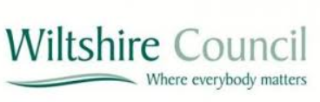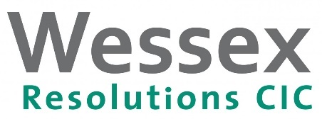
Funding available to homeowners and landlords for home improvements
Wiltshire Council would like to make residents aware of funding that is available to make improvements to homes in our area.
Homeowners and landlords can apply for a loan to make improvements to their homes. Essential home repairs such as a replacement boiler, new windows and doors, roof repairs (including thatch), plumbing, heating or electrical works and even structural repairs are included under the scheme.
Everyone receives the same interest rate, whether you borrow £1,000 or £15,000 and no matter what your circumstances or credit score. Eligible homeowners choose their own contractor and there are a variety of loan products available to suit individual needs*.
The scheme is delivered through Wessex Resolutions, a not-for-profit lender that works in close partnership with the council. Established in 2003, Wessex Resolutions has helped many homeowners throughout the South West, lending almost £13.6 million. A recent client said "I had no idea the scheme existed until I contacted the Council. When my adviser visited me and explained everything perfectly it was a huge burden lifted from me – loan repayments that I can afford and the efficiency with which it was all arranged. I am truly grateful to all concerned.”

For more information, call Wessex Resolutions on 01823 461099, visit www.wessesxresolutions.org.uk or email enquiries@wrcic.org.uk.
(*subject to eligibility)
Loans have a fixed interest rate and typical 4.2% APR. Missing payments could affect your credit rating and ability to obtain credit in the future. Loans are typically protected by a Title Restriction and are subject to status.
Wessex Resolutions C.I.C.: a community interest company limited by guarantee, registered in England, company number 4512225. Registered address: Heatherton Park Studios, Bradford on Tone, Taunton TA4 1EU. Wessex Loans and Wessex Home Improvement Loans are trading names used by this company. Wessex Resolutions C.I.C is authorised and regulated by the Financial Conduct Authority (675263) for credit and debt-related regulated activities.

